Interaction diagrams：11. 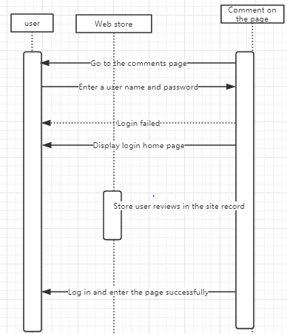

explain: The user enters account number and password, login success goes to main page directly. Click on the comment page and the user can comment. After the comment is successful, the system stores the comment record directly in the website store.

12. 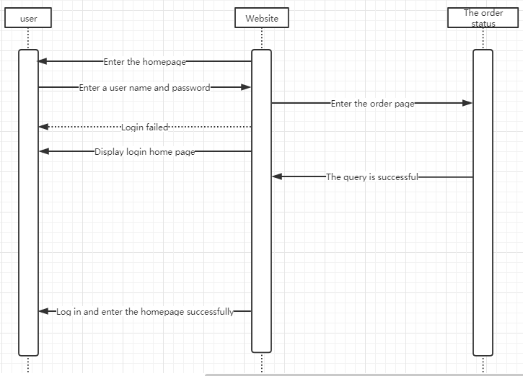

explain：Users login to the website page and click to purchase. View the order status of the purchased item in the purchased item.